**Stage 2**

**RULES:** USPSA Competition Rules, Latest Edition **COURSE DESIGNER:** Ryan Christenson

|  |  |
| --- | --- |
| **START POSITION: See written stage briefing.** | |
| **STAGE PROCEDURE**  See written stage briefing. | **SCORING**  **SCORING:** Comstock 31 rounds.  **TARGETS:** There are 15 cardboard targets and one steel target.  **SCORED HITS:** 2 Best hits per carboard will be scored. Steel must fall to score.  **START-STOP:**  Audible - Last shot  **PENALTIES:** Per USPSA Competition Rules |

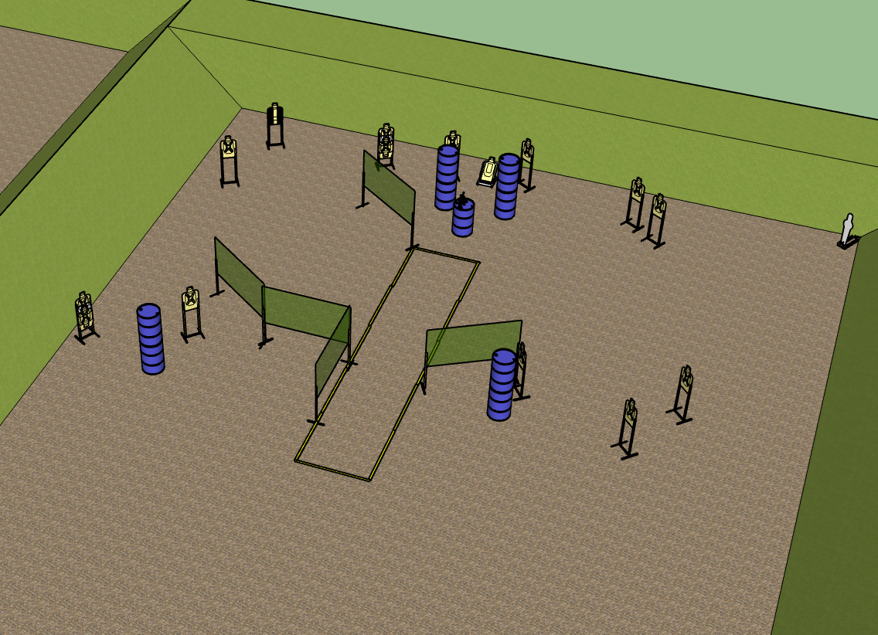

**Written Stage Briefing:**

**Stage 1 –** is a 31-round, 155 point, Comstock Long Course. There are 15 cardboard targets and 1 steel target. The best 2 hits per cardboard target will be scored. The steel must fall to score.

**Start position** Standing inside the shooting area. Gun is loaded and placed on start barrel.

On the audible start signal, engage targets from within the shooting area.

**Setup Notes:**

For the center low target, make sure it is as close to the berm as possible.  
Be sure to hydrate yourself.